New Technique to Make Stem Cell Therapy Reality
Washington: The mesenchymal stem cells found in the bone marrow can give rise to bone, fat, and muscle tissue, and have been used in hundreds of clinical trials for tissue repair.

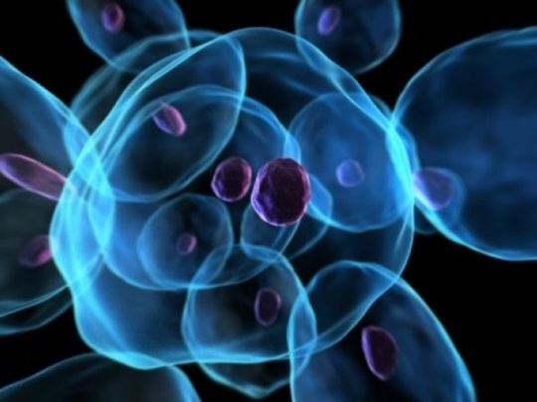

Unfortunately, the results of these trials have been underwhelming, the main problem being that these stem cells do not stick around in the body long enough to benefit the patient.

Researchers have now found that transplanting mesenchymal stem cells along with blood vessel-forming cells naturally found in circulation improves results.

This co-transplantation keeps the mesenchymal stem cells alive longer in mice after engraftment, up to a few weeks compared to hours without co-transplantation. This improved survival gives the mesenchymal stem cells sufficient time to display their full regenerative potential, generating new bone or fat tissue in the recipient mouse body.

"We are losing mesenchymal stem cells very rapidly when we transplant them into the body, in part, because we are not giving them what they need," said Juan Melero-Martin, an assistant professor of surgery at Boston Children's Hospital, Harvard Medical School in the US.

"In the body, these cells sit very close to the capillaries, constantly receiving signals from them, and even though this communication is broken when we isolate mesenchymal stem cells in a laboratory dish, they seem to be ok because we have learned how to feed them," he added.

"But when you put the mesenchymal stem cells back into the body, there is a period of time when they will not have this proximity to capillary cells and they start to die; so including these blood vessel-forming cells from the very beginning of a transplantation made a major difference," Melero-Martin explained.

The finding was published in the Proceedings of the National Academy of Sciences.

